Comparative Efficacy Test Over an Open Fire Plan

[Reference](https://www.youtube.com/watch?v=Fid8oT7mueY&list=PLD18AUvtiwg8bN6_3LNzJZYOMcsJ8-aH7&index=20&ab_channel=SpinifexTreknTrail) Test

* 2-3 minutes to boil 1L water

Materials:

* [~~Thermal Camera for iPhone~~](https://www.amazon.com/FLIR-One-Thermal-Imager-For/dp/B0728C7KND/ref=sr_1_3?dchild=1&keywords=Thermal+Imaging+Camera+for+iOS&qid=1604234993&sr=8-3) ~~$199.99~~
* Fire starter $3.95
* Fire wood
* ~~Fire pit?~~
* ~~Regular pot~~
  + [~~Sea to summit alpha pot 1.9 L $44.95~~](https://www.rei.com/product/128506/sea-to-summit-alpha-pot-19-liters)
    - ~~Best Use Backpacking Liquid Capacity (L) 1.9 liters Liquid Capacity (fl. oz.) 64 fluid ounces~~
    - ~~Dimensions 6.5 x 4.7 inches~~
    - **~~Cookware Material Aluminum Material(s) Hard-anodized alloy~~**
    - **~~Nonstick Surface No~~**
    - ~~Includes 1.9L pot; strainer lid Weight 8.1 ounces~~
  + [GSI boiler pot 1.8 L $37.50](https://www.rei.com/product/107822/gsi-outdoors-halulite-boiler-pot-18-liters)
    - Liquid Capacity (L) 1.8 liters Liquid Capacity (fl. oz.) 61
    - **Dimensions 6.0 x 5.8 x 5.6 in. inches**
    - **Cookware Material Aluminum Material(s) Hard Anodized Aluminum**
    - Nonstick Surface No Includes
    - 1.8 Liter Boiler, Lid, Mesh Stuff Sack Weight 11 oz. ounces
* ~~Heat exchanger pot~~
  + [GSI pot 1.8 L $89.95](https://www.rei.com/product/165301/gsi-outdoors-pinnacle-dualist-hs-cookset)
    - Best Use Backpacking
    - **Dimensions 6.2 x 5.9 x 5.8 inches** Cookware
    - **Material Stainless Steel Material(s) Nonstick coated/hard anodized aluminum/PP/nylon/silicone/aluminum/stainless steel**
    - **Nonstick Surface Yes**
    - Includes 1.8L pot strainer lid; 2 mugs (20 fl. oz.) with insulated sleeves; 2 bowls (20 fl. oz.); 2 sip-it tops; 2 folding foons; welded sink Ultralight Yes Weight 1 lb. 7.1 oz.
  + [MSR wind burner duo pot 1.8 L $179.95](https://www.rei.com/product/897576/msr-windburner-pot-18-liters)
    - Best Use Backpacking Liquid Capacity (L) 1.8 liters Liquid Capacity (fl. oz.) 61 fluid ounces
    - **Dimensions 5 x 8 inches**
    - **Cookware Material Aluminum Material(s) Aluminum/plastic**
    - Includes Pot; strainer/drinking lid; cozy; bowl; canister stand Weight 13 ounces

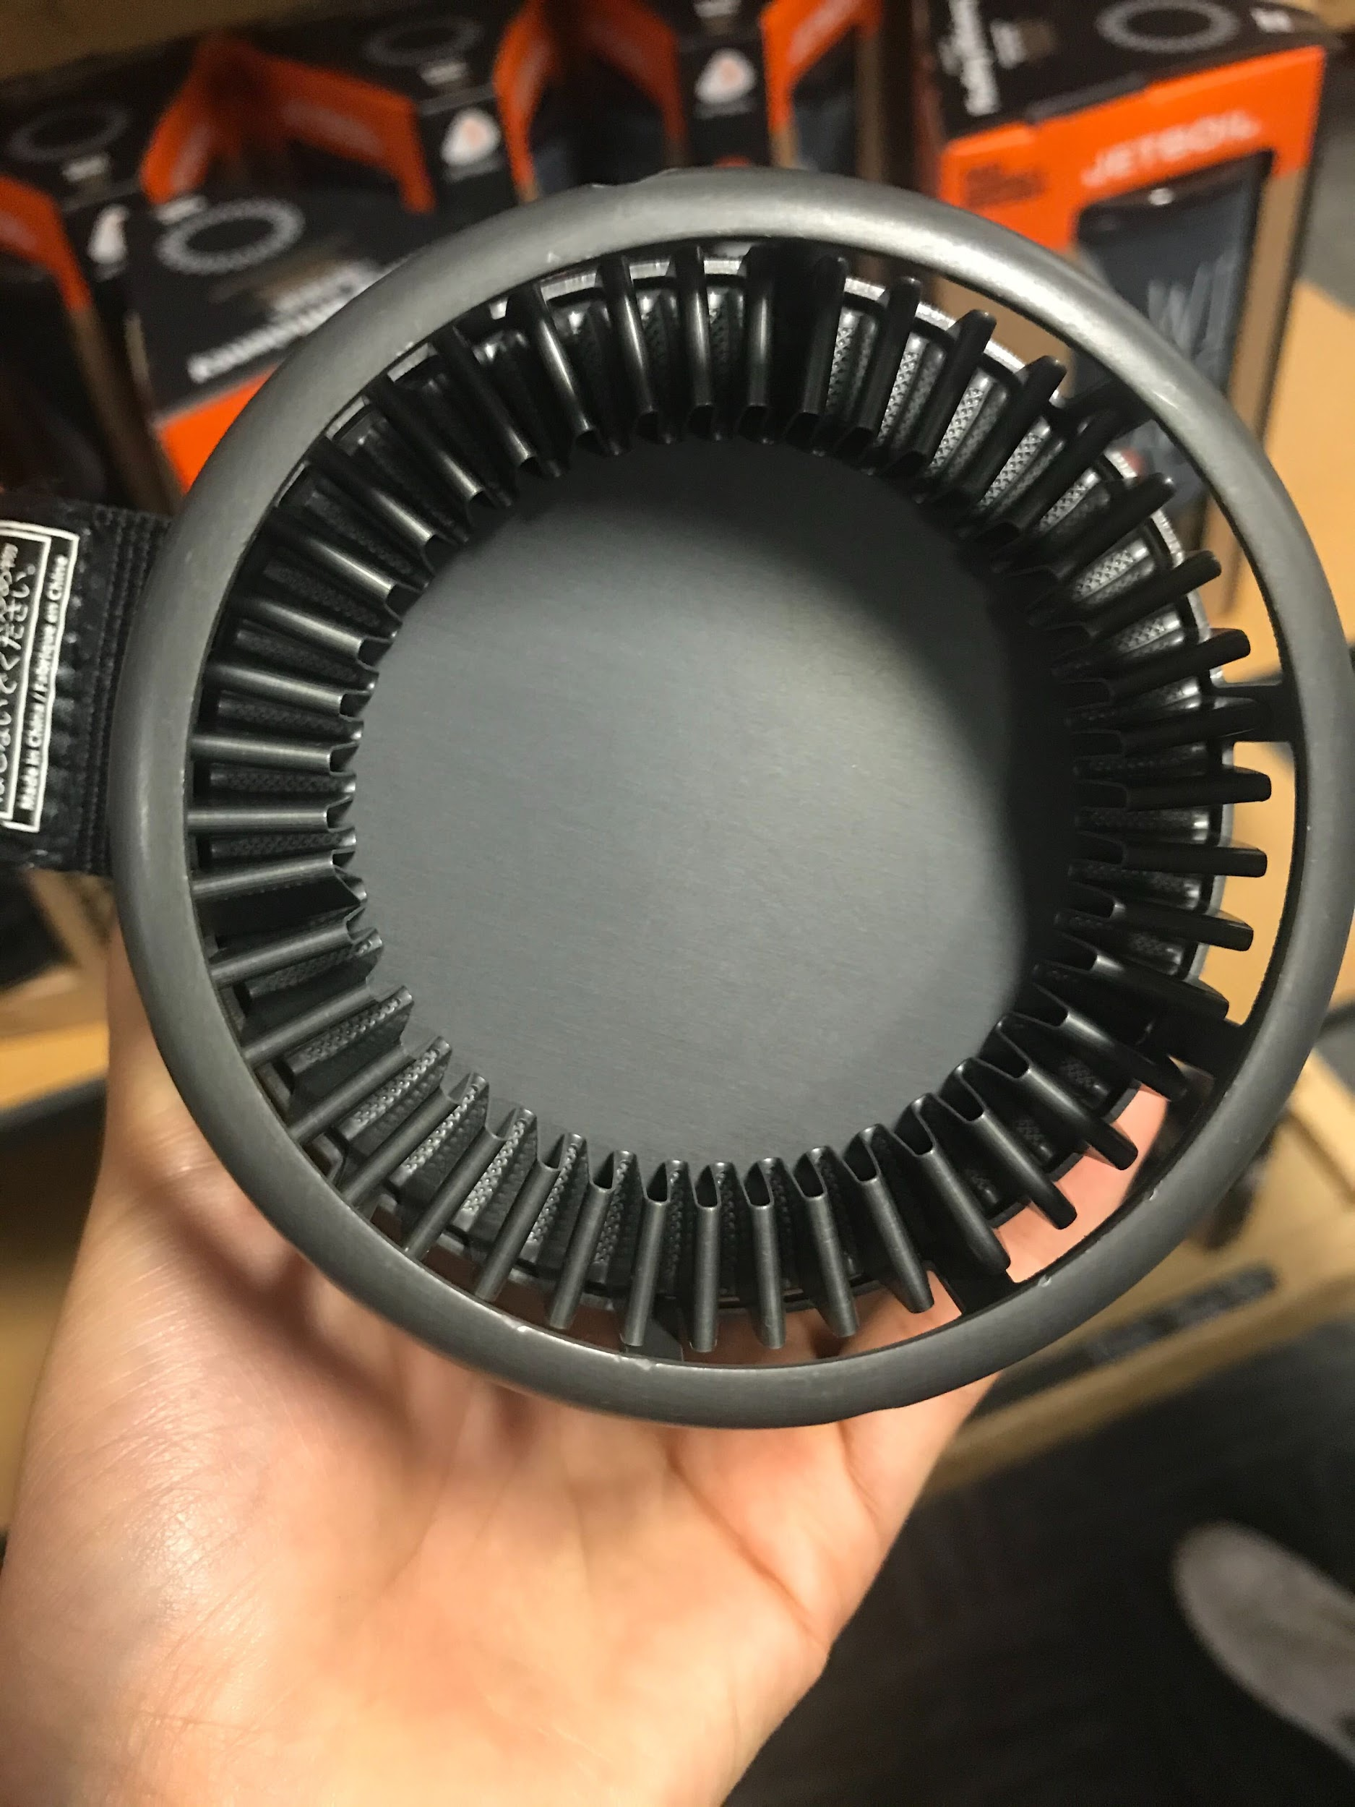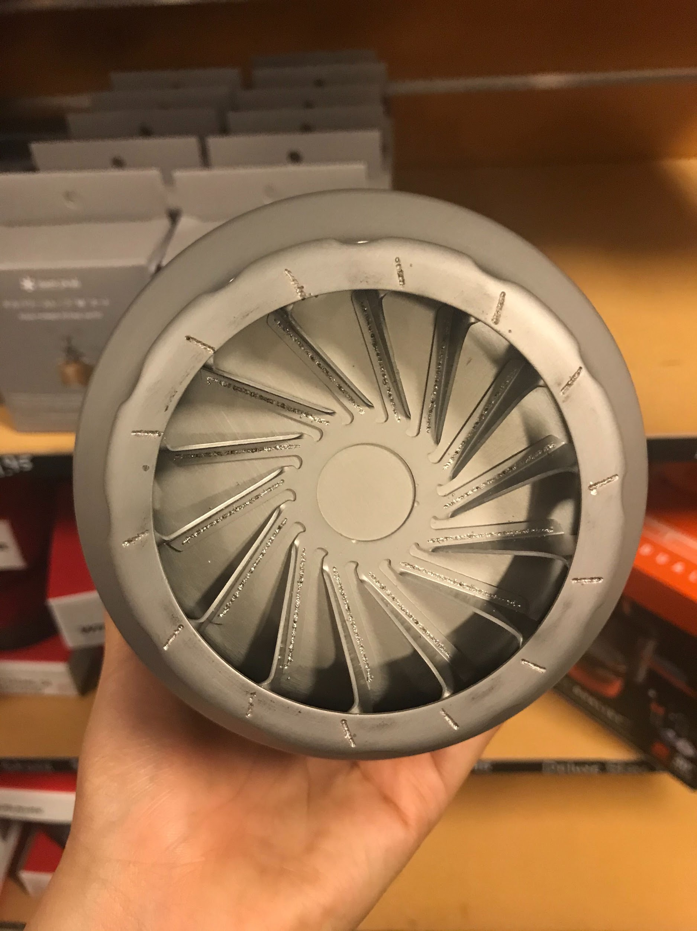

* OEDK
  + thermometers
  + Thermocouplers
  + IR gun
* MISC
  + Measuring cup
  + Oven mitts
  + Tongs
  + ~~Rocks - Home Depot/Lowe’s~~
    - Landscaping store
  + 3 gallons of distilled water

[Location](https://houston.cbslocal.com/top-lists/top-spots-for-a-bonfire-in-houston/): Call to confirm that we can start a fire

* McMurty - ask if we can start a fire? (Brian Gibson)
* Hanszen -
* Someone’s backyard
  + Sana’s?
* Sheldon Lake (281) 456-2800
* SFA (979) 885-3613
* Galveston State park 9798853613
* Lake Livingston State Park (936) 365-2201
* (take a picture of gas/miles before and after + keep receipts)

Procedure

1. Set up the stones or something else to support the pot
2. Set up the fire
   1. Take three separate measures of the fire’s temp with the IR gun
3. Measure the temperature of the distilled water at room temperature
   1. Take three separate measures
4. Fill the pot with 1.5L of room temperature water and put on the fire
   1. If the thermometer fits (for both the lid and without lid test), leave it in the water
   2. Once the water has boiled record the temperature from the thermometer
5. Point the IR camera at the pot and record until the water has boiled
6. Meanwhile point the IR gun at the bottom of the pot (if possible…)
   1. Take three separate measures every 30 seconds
7. Once the water has boiled take the pot off of the fire
   1. Place down where?
   2. Continue recording the pot with the IR camera for 5? 10? Minutes afterwards
      1. To see how and the time it takes for the heat to dissipate
8. Repeat will all the pots

Questions

* Will we be measuring the time it takes to boil with a lid and without a lid?
  + With a lid test
    - how will I check to see if the water is boiling without lifting the lid too many times?
    - How will I check temperature - depending on length of the thermometer, it may prevent the lid from closing all the way